HANDS ON EXCERCISE

1.Write a Java program to simulate a simple login system.

import java.util.Scanner;

public class LoginSystem {

public static void main(String[] args) {

String username = "admin";

String password = "12345";

Scanner sc = new Scanner(System.in);

System.out.print("Enter username: ");

String inputUser = sc.nextLine();

System.out.print("Enter password: ");

String inputPass = sc.nextLine();

if (username.equals(inputUser) && password.equals(inputPass)) {

System.out.println("Login Successful!");

} else {

System.out.println("Invalid Credentials.");

}

}

}

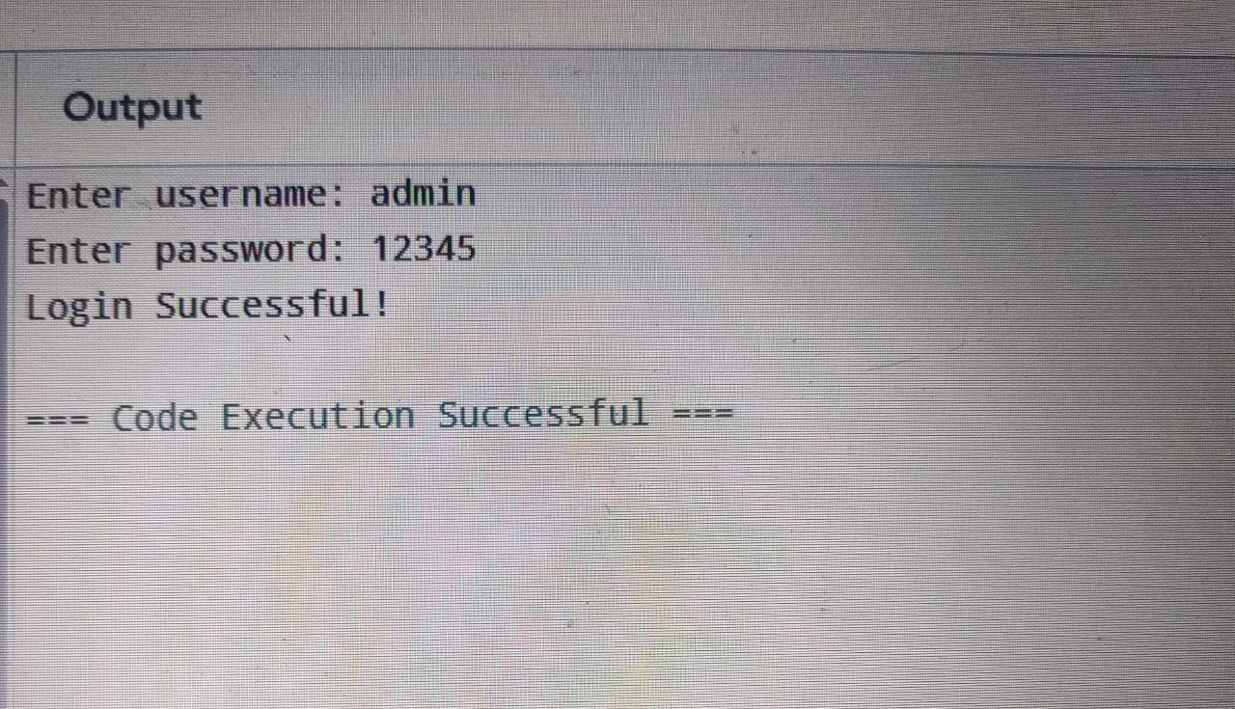

2.Java program to simulate REST-style output for a user profile (like an API).

public class UserAPI {

public static void main(String[] args) {

int id = 101;

String name = "John Doe";

String email = "john@example.com";

System.out.println("{");

System.out.println(" \"id\": " + id + ",");

System.out.println(" \"name\": \"" + name + "\",");

System.out.println(" \"email\": \"" + email + "\"");

System.out.println("}");

}

}

